Babiators “Screen Savers”

Blue Light Protection Glasses

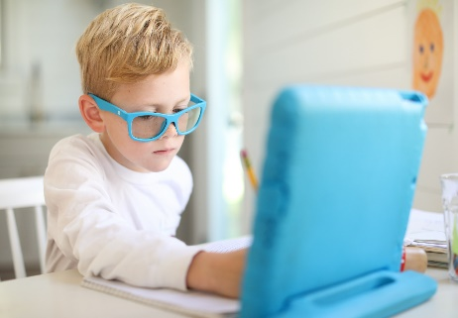      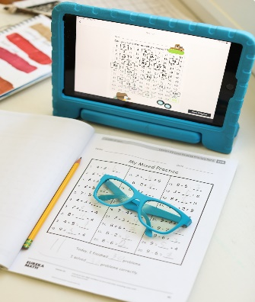

Here are the DETAILS:

**ALL NEW** Screen Saver glasses from Babiators will help you protect your children’s eyes from overexposure to digital screens. We took the Babiators keyhole style and Navigator Style that kids and parents love and added blue light blocking lenses to create Babiators Screen Savers to make screen time safer for your family.

These glasses block 55% of Blue Light through **Category 1 lenses** to decrease blue light exposure. Although blue light is naturally occurring, kids are receiving an unnaturally high exposure since they are spending more time on devices. That high blue light exposure is linked to trouble falling asleep at night and may contribute to increased eye strain.

Grab your favorite color Screen Savers and be the coolest (and safest) kid on your school video chat!

**See Line Sheet for color and style choices.**

**$10.50 Wholesale**

**2 sizes offered: 3-5 years and 6+ years**